**SECTION A (60 Marks)**

Answer only **three** questions from this section.

1. Distinguish between nuclear fission and nuclear fusion. (02 marks)
2. state two:
3. Differences between nuclear reactions and ordinary chemical reactions. (02 marks)
4. Applications of radionuclides. (02 marks)
5. The table below shows the kinetic data that were obtained for radioactive decay of element, Z.

|  |  |  |  |  |  |
| --- | --- | --- | --- | --- | --- |
| Time (minutes) | 0 | 40 | 80 | 120 | 160 |
| Mass of element, Z (gram) | 60.0 | 38.5 | 26.0 | 17.2 | 11.1 |

Plot a graph of mass of element, Z against time. (03 marks)

1. Use the graph in (c) above, to determine the:
2. Half-life of element, Z. (02 marks)
3. Decay constant and indicate its S.1 units. (02 marks)
4. Fraction of element, Z that remained after 200 minutes. (02 marks)
5. The table below gives data from a mass spectrometer about an element, Q.

|  |  |
| --- | --- |
| Isotopic mass | Relative abundance |
| 23.98 | 78.60 |
| 24.98 | 10.11 |
| 25.98 | 11.29 |

1. Define the term isotopes. (01 mark)
2. Calculate the average atomic mass of element, Q. (03 marks)
3. State two merits of using mass spectrometer to determine the relative atomic masses. (02 marks)
4. Chromium is classified as both d-block and transition elements.
5. Distinguish between a d-block and transition element. (02 mks)
6. State three properties in which chromium behaves as a transition element. (03 marks)
7. (i) Write the equation half-equation for the reaction of potassium dichromate (VI) in acidic medium. (01½ marks)
8. State the change in oxidation state of the chromium in the reaction b (i) above. (01 mark)
9. State three advantages of using potassium dichromate (VI) in volumetric analysis. (01½ marks)
10. Write the equation for the reaction that place when place chromium (III) chloride is dissolved in water. (01½ marks)
11. Explain what would be observed when:
12. Concentrated sodium carbonate solution is added to the resultant solution in d (i). (04½ marks)
13. Aqueous sodium hydroxide solution is added drop wise to the resultant solution in d (i). (05 marks)

1. Complete the following equations and in each case outline the mechanism for the reaction.
2. 
3. 
4. 
5. 
6. 
7. 
8. State what is meant by the following terms: (@01 mark)
9. Enthalpy of solution.
10. Enthalpy of reaction.
11. Standard heat displacement.

Excess zinc dust was added to 25.0cm3 of 1.0M copper (II) sulphate solution in a plastic beaker and the temperature of the resultant mixture recorded at some time intervals. The data obtained is shown below. [Assume: S.H.C soln = 4.2J/g/K]

|  |  |  |  |  |  |  |  |
| --- | --- | --- | --- | --- | --- | --- | --- |
| Time (minutes) | 0 | 2.5 | 3.0 | 3.5 | 5.0 | 6.0 | 7.0 |
| Temperature(ᵒC) | 27.2 | 66.0 | 69.5 | 68.5 | 65.0 | 62.0 | 59.5 |

1. Write ionic equation for the reaction that took place. (01 mk)
2. Plot a graph of temperature against time. (04 marks)
3. Use the graph in b (ii) to determine the molar enthalpy of the reaction. (04 marks)
4. The solubility of ionic salts in water depends on two factors namely, lattice energy and hydration energy. Explain how hydration energy affects the solubility of ionic salts in water.
5. Some thermochemical data are given below:

Process Energy [kJ/mol]

Atomization of calcium +178

First ionization energy of calcium +590

Second ionization energy of calcium +1,146

Formation of calcium fluoride -1,220

First electron affinity of fluorine -328

Atomization energy of fluorine +121.4

Calculate the lattice energy of calcium fluoride crystal.

**SECTION B (40 Marks)**

Answer only **two** questions from this section.

1. Nitrogen and hydrogen react to form ammonia according to the following equation below:N2(g) + 3H2(g) 2NH3(g) ∆H = -92kJ/mol
2. Name one source of nitrogen and hydrogen for use in the manufacture of ammonia. (01 mark)
3. State what would happen to the equilibrium position and in each case give a reason, if: (01½ marks)
4. Pressure of the system is increased.
5. Temperature of the system is increased.
6. Iron is added to the system.
7. Using equations, describe how ammonia can be converted in to nitric acid. (05 marks)
8. Explain what would be observed when:
9. Concentrated nitric acid is heated. (02 marks)
10. Hot concentrated nitric acid is added to copper turnings. (03)
11. 5.0g of ammonium salt, R was boiled with 100.0cm3 of 2.0M sodium hydroxide solution for about 10 minutes. The resultant mixture was diluted to 200.0cm3 with more water.25.0cm3 of the diluted solution required 22.4cm3 of 0.5M hydrochloric acid for complete neutralization using methyl orange. Calculate the mass of ammonia in R. [R = 53.5] R reacts with sodium hydroxide solution according to the following equation. (04 marks)

NH4+(aq) + OH-(aq)  NH3(g) + H2O(l)

1. State one industrial use of nitric acid. (0½ marks)
2. Write equations to show how the following compounds can be synthesized.
3. Benzoic acid from ethyne. (03½ marks)
4. Methylethanoate from bromoethane. (04½ marks)
5. Propan-2-ol from propanoic acid. (03½ marks)
6. But-2-yne from butan-1-ol. (03½ marks)
7. But-1-yne from chloroethane. (05 marks)
8. Define the term acid-base indicator. (01 mark)
9. Hydrochloric acid was added to 25.0cm3 of 0.1M ammonia solution and pH of the resultant solution was measured at intervals. The data obtained are given in the table below.

|  |  |  |  |  |  |  |  |
| --- | --- | --- | --- | --- | --- | --- | --- |
| Vol.HCl acid(cm3) | 0.0 | 10.0 | 15.0 | 16.5 | 17.0 | 20.0 | 25.0 |
| pH of the mixture | 10.20 | 9.08 | 8.30 | 6.70 | 2.97 | 1.96 | 1.60 |

1. Plot a graph of pH against volume of hydrochloric acid. (03 marks)
2. Explain the graph shape. (05 marks)
3. Calculate the molarity of hydrochloric acid. (03 marks)
4. The pH ranges of some selected indicators are shown below:

|  |  |
| --- | --- |
| Indicator | pH range |
| Thymol blue | 1.2-2.8 |
| Methyl red | 4.8-6.0 |
| Phenolphthalein | 6.6-8.0 |

Which one of the above indicators is most suitable for the above titration? Explain your answer. (01½ marks)

1. What is buffer solution? (01 mark)
2. Explain the working of an alkaline buffer. Use a suitable example to illustrate your answer. (05 marks)
3. State two uses of buffer solutions. (01 mark)
4. Explain the following observations.
5. Iron (II) compounds are more stable than iron (II) compounds. (02 marks)
6. The first electron affinity of phosphorous is less than that of sulphur. (03½ marks)
7. Lithium carbonate decomposes when heated strongly whereas sodium carbonate does not. (03 marks)
8. When water is added lead (IV) chloride, white fumes are observed and a brown precipitate is formed. (02 marks)
9. Bromocyclohexane undergoes nucleophilic substitution reaction when heated with aqueous sodium hydroxide solution whereas bromobenzene does not react under similar treatment. (04 marks)
10. When concentrated hydrochloric acid was added to lead (II) nitrate solution drop wise until excess, a white precipitate was formed that dissolved in excess concentrated hydrochloric acid to form a colourless solution. (05 marks)

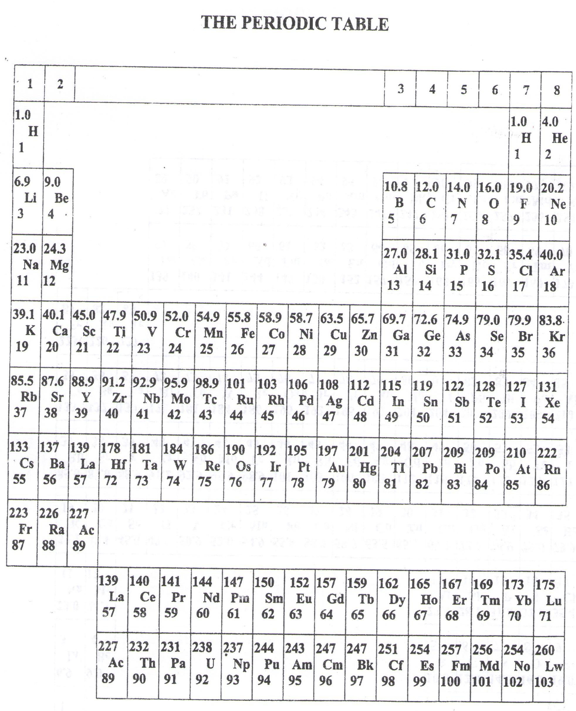

* ===END===

WELCOME TO SENIOR SIX, YEAR 2023

This is the last page of the printed paper, Page 07